* **Language Implimitation**

**Step : 1**  Add the Resource File in Project UI

* UI

Resources (Folder Name)

SharedResource.resx created SharedResource file

If multiple language then multiple file language wise create

(eg. SharedResource.fr.resx(franch), SharedResource.pt.resx(Portuguese))

* Add the Label Name Language wise

Screen short for Resource file and Folder Structure

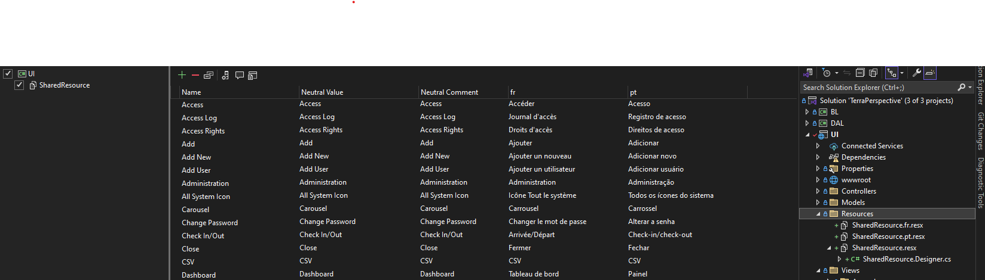

**Step : 2** Configuration in Program.cs file

* Add Code Localization Services

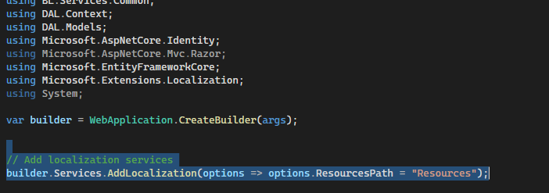

And set the Required Language values like (en-US, fr-FR)

* And some Other code are Added in Program.cs file

app.UseRequestLocalization();

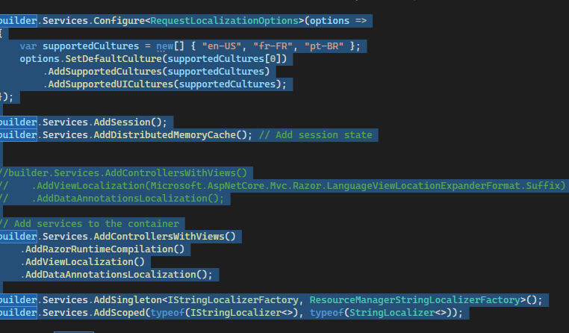

**Step : 3** Add Dropdown in Header and New Controller add for Language Changed

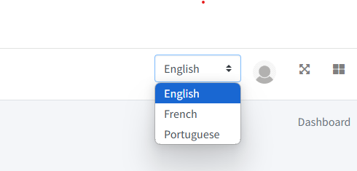

Set the Culture if Language and Default Pass the Culture “English(en-US)”

And Set Culture in Session for selected values get in dropdown

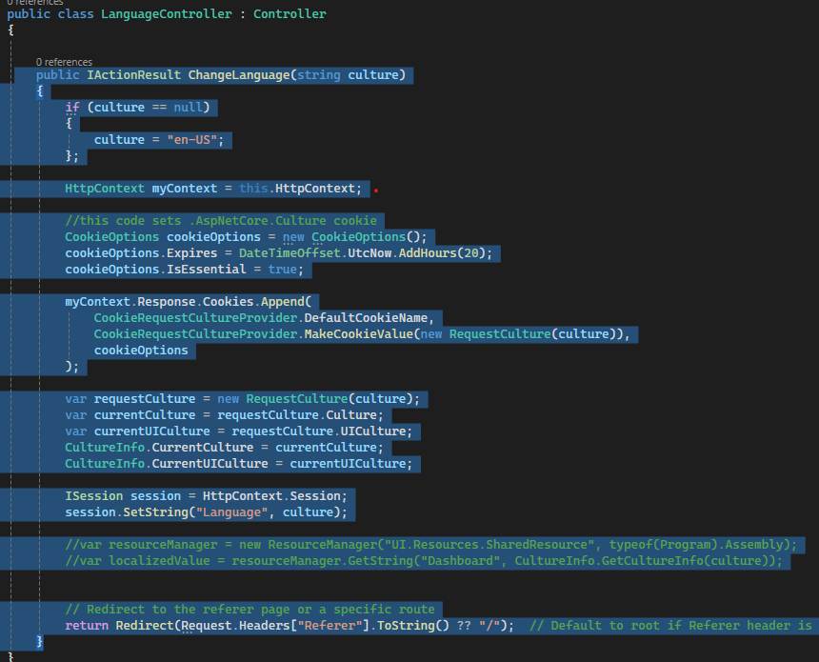

**Step : 4** Used for .cshtml Page

Add the Namespace for Resources Folder (like : @using UI.Resources)

Label Name are apply like User - > @SharedResource.User

Share a Screenshot

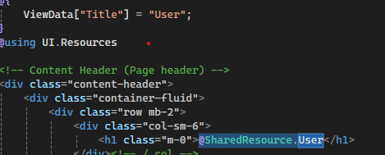

The User Label Name set in Resources - SharedResource.resx file for different language



All .cshtml file for used @ResourceFileName.YourLabelName

**Step : 5** Used for Common JS file

For a List Header Value

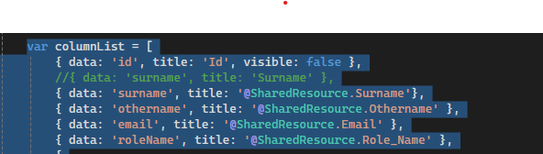

Only Pass Required Label in common Function

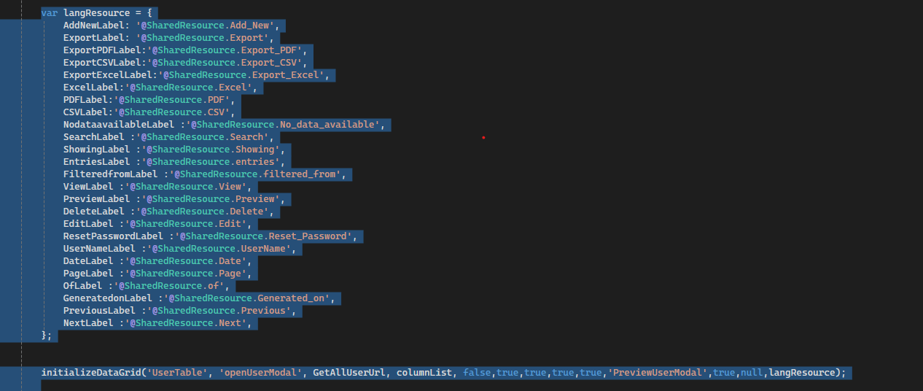

And User in JS File for set variable name and used the variable like this Image



Used this variable like this

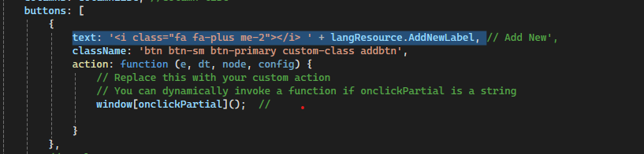

**Step : 6** For A Sidebar Menu

Add All Menu Name in Your Resource file

Set the Menu Label Name in _Layout.cshtml file

And if in Case new menu Add then Also Add this file

Menu Common.js file also apply Condition wise add menu

_Layout.cshtml file

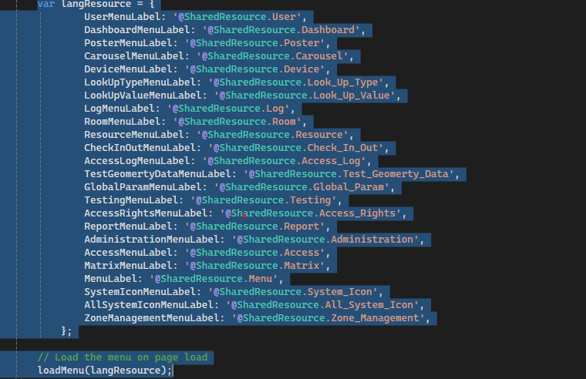

Common.js File for an Added Menu condition wise check menu and apply the Language

